Contents
SL.NO | particulars | PAGE.NO
1 | Abstract | 2
2 | System Specifications | 3
3 | Introduction to openGL | 4
5 | Implementation | 7
6 | Interaction | 9
7 | Source Code | 10
8 | Output | 29
9 | Conclusion | 31
10 | Bibliography | 32

Abstract

- Main aim of this Mini Project is to illustrate the concepts and usage of Fire Wall in OpenGL.
- A firewall can either be software-based or hardware-based and is used to help keep a network secure.
- Its primary objective is to control the incoming and outgoing network traffic by analyzing the data packets and determining whether it should be allowed through or not, based on a predetermined rule set.
- A network's firewall builds a bridge between the internal network or computer it protects, upon securing that the other network is secure and trusted, usually an external (inter)network
- We have used input devices like mouse and key board to interact with program.
- We have also used SolidCube for forming a complete network setup which help to understand concept of Congestion Control very well.
- To differentiate between objects we have used different colors for different objects.
- We have added menu which makes the program more interactive.
- In this project we have used a small SolidCube to represent a data, which travels as data transfer from source to destination.
- We have used font family for indicating the name of objects as we can see in this project.

System specifications

- SOFTWARE REQUIREMENTS :
- MICROSOFT VISUAL C++
- OPENGL

- OPERATING SYSTEM :

- WINDOWS XP,VISTA

- HARDWARE REQUIREMENT :

- GRAPHICS SYSTEM,
- Pentium P4 with 256 of Ram(Min)

Introduction to openGL

As a software interface for graphics hardware, OpenGL's main purpose is to render two- and three-dimensional objects into a frame buffer.
These objects are described as sequences of vertices or pixels.
OpenGL performs several processing steps on this data to convert it to pixels to form the final desired image in the frame buffer.

OpenGL Fundamentals
This section explains some of the concepts inherent in OpenGL.

Primitives and Commands
OpenGL draws primitives—points, line segments, or polygons—subject to several selectable modes.
You can control modes independently of each other; that is, setting one mode doesn't affect whether other modes are set .Primitives are specified, modes are set, and other OpenGL operations are described by issuing commands in the form of function calls.
Primitives are defined by a group of one or more vertices. A vertex defines a point, an endpoint of a line, or a corner of a polygon where two edges meet. Data is associated with a vertex, and each vertex and its associated data are processed independently, in order, and in the same way. The type of clipping depends on which primitive the group of vertices represents.
Commands are always processed in the order in which they are received, although there may be an indeterminate delay before a command takes effect. This means that each primitive is drawn completely before any subsequent command takes effect. It also means that state-querying commands return data that's consistent with complete execution of all previously issued OpenGL commands.

Basic OpenGL Operation
The figure shown below gives an abstract, high-level block diagram of how OpenGL processes data. In the diagram, commands enter from the left and proceed through what can be thought of as a processing pipeline. Some commands specify geometric objects to be drawn, and others control how the objects are handled during the various processing stages.
Figure . OpenGL Block Diagram

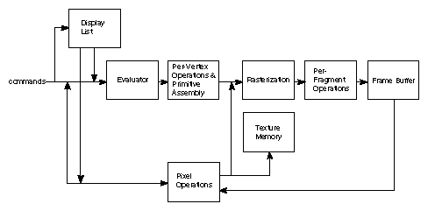

As shown by the first block in the diagram, rather than having all commands proceed immediately through the pipeline, you can choose to accumulate some of them in a display list for processing at a later time.
Rasterization produces a series of frame buffer addresses and associated values using a two-dimensional description of a point, line segment, or polygon.
Each fragment so produced is fed into the last stage,
per-fragment operations, which performs the final operations on the data before it's stored as pixels in the frame buffer. These operations include conditional updates to the frame buffer based on incoming and previously stored z-value s (for z-buffering) and blending of incoming pixel colors with stored colors, as well as masking and other logical operations on pixel values.
All elements of OpenGL state, including the contents of the texture memory and even of the frame buffer, can be obtained by an OpenGL application.

Implementation

This program is implemented using various openGL functions which are
shown below.
Various functions used in this program.
- glutInit() : interaction between the windowing system and OPENGL is initiated

- glutInitDisplayMode() : used when double buffering is required and depth information is required

- glutCreateWindow() : this opens the OPENGL window and displays the title at top of the window

- glutInitWindowSize() : specifies the size of the window

- glutInitWindowPosition() : specifies the position of the window in screen co-ordinates

- glutKeyboardFunc() : handles normal ascii symbols

- glutSpecialFunc() : handles special keyboard keys

- glutReshapeFunc() : sets up the callback function for reshaping the window

- glutIdleFunc() : this handles the processing of the background

- glutDisplayFunc() : this handles redrawing of the window

- glutMainLoop() : this starts the main loop, it never returns

- glViewport() : used to set up the viewport

- glVertex3fv() : used to set up the points or vertices in three dimensions

- glColor3fv() : used to render color to faces

- glFlush() : used to flush the pipeline

- glutPostRedisplay() : used to trigger an automatic redrawal of the object

- glMatrixMode() : used to set up the required mode of the matrix

- glLoadIdentity() : used to load or initialize to the identity matrix

- glTranslatef() : used to translate or move the rotation centre from one point to another in three dimensions

- glRotatef() : used to rotate an object through a specified rotation angle

Interaction with program

- .Both mouse and keyboard are used to interact with the program.
- S key to Start the project.
- Right mouse button can be used to get a menu.

Source Code

#include <windows.h>
#include<string.h>
#include<stdarg.h>
#include<stdio.h>
//#include<math.h>
#include <glut.h>
// co ordinates of eight packets
static double x=0,y=0,z=0,i1=0;

// p[8] is used to generate 8 different packets, 4 for each user. usind the keys 1-8
// u[8] is used to Allow or deny packets using menu,
//the order is for "user 1" u[0-3]={http,telnet,ssh,smtp} & for "user 2" u[0-3]={http,telnet,ssh,smtp}

static bool p[8]={false}, u[8]={false};
//t1=false,sh1=false,sm1=false;
//static bool tt2=false,h2=false,sh2=false,sm2=false;

void *font;
void *currentfont;

void setFont(void *font)
{
currentfont=font;
}

void drawstring(float x,float y,float z,char *string)
{
char *c;
glRasterPos3f(x,y,z);

for(c=string;*c!='\0';c++)
{ glColor3f(0.0,1.0,1.0);
glutBitmapCharacter(currentfont,*c);
}
}

void
stroke_output(GLfloat x, GLfloat y, char *format,...)
{
va_list args;
char buffer[200], *p;
va_start(args, format);
vsprintf(buffer, format, args);
va_end(args);
glPushMatrix();
glTranslatef(-2.5, y, 0);
glScaled(0.003, 0.005, 0.005);
for (p = buffer; *p; p++)
glutStrokeCharacter(GLUT_STROKE_ROMAN, *p);
glPopMatrix();
}

void server()
{
glPushMatrix();
glScaled(0.8,2.0,0.8);
glTranslatef(-0.5,0,-15);
glColor3f(0,1.5,1.5);
glutSolidCube(1);

glPushMatrix();
glScaled(0.5,.1,1.0);
glTranslatef(.0,3.5,0.01);
glColor3f(0.3,0.3,0.3);
glutSolidCube(1.5);
glPopMatrix();

glPushMatrix();
glScaled(0.35,.05,1.0);
glTranslatef(0.0,1,0.1);
glColor3f(0,0,0.3);
glutSolidCube(1.1);
glPopMatrix();

glPushMatrix();
glScaled(2.2,.1,1.0);
glTranslatef(0,-1,0.3);
glColor3f(0,0,1.3);
glutSolidCube(0.5);
glPopMatrix();

glPushMatrix();
glScaled(2.2,.1,1.0);
glTranslatef(0,-2,0.3);
glColor3f(0,0,1.3);
glutSolidCube(0.5);
glPopMatrix();

glPushMatrix();
glScaled(2.2,.1,1.0);
glTranslatef(0,-3,0.3);
glColor3f(0,0,1.3);
glutSolidCube(0.5);
glPopMatrix();

glPopMatrix();
}

void plane()
{
glScaled(0.2,0.1,0.3);
if(p[0] || p[4])
glColor3f(1,1,0);

if(p[1] || p[5])
glColor3f(0,1,0);

if(p[2] || p[6])
glColor3f(1,0,0);

if(p[3] || p[7])
glColor3f(0,1,1);

glutSolidSphere(1.0,40,40);

glPushMatrix();
glColor3f(0,0,0);
glTranslatef(0,0,0);
glScaled(3,0.3,0.01);
glutSolidSphere(1.0,40,40);
glPopMatrix();

glPushMatrix();
glColor3f(0,0,0);
glTranslatef(0,2,0.8);
glScaled(0.2,3,0.01);
glutSolidSphere(1.0,40,40);
glPopMatrix();

}

void wall(){

glPushMatrix();
glTranslatef(-1.5,-0.05,-6);
glColor3f(1,1,1);
glScaled(4.7,3.05,0.2);
glutSolidCube(1);
glPopMatrix();

for(float y=-5;y<=5;y+=0.65){
for(float x=-5.3; x<=1;x+=0.57){
glPushMatrix();
glColor3f(0.4,0.4,0.4);
glScaled(.7,0.3,0.5);
glTranslatef(x,y,-12);
glutSolidCube(0.5);
glPopMatrix();
}
}
}

void user()
{
glPushMatrix();
glColor3f(1,1,1);
glTranslatef(0,1.2,1);
//glScaled(0.3,0.35,0.01);
glutSolidSphere(0.4,40,40);
glPopMatrix();

glPushMatrix();
glColor3f(1,1,1);
glTranslatef(0,0,1);
glScaled(0.6,1.7,0.6);
glutSolidSphere(0.6,40,40);
glPopMatrix();

glPushMatrix();
glColor3f(1,1,1);
glTranslatef(0.35,-0.1,1);
glScaled(0.2,2,0.2);
glRotatef(90,1,0,0);
glutSolidTorus(0.2,0.4,40,40);
glPopMatrix();

glPushMatrix();
glColor3f(1,1,1);
glTranslatef(-0.3,-0.1,1.2);
glScaled(0.2,2,0.2);
glRotatef(90,1,0,0);
glutSolidTorus(0.2,0.4,40,40);
glPopMatrix();
}

//PC Computers
void pc()
{

glPushMatrix();
glTranslatef(0,0,3);
glScaled(.7,.7,0);
glColor3f(0,1,0);
glutSolidCube(1);

glPushMatrix();
glColor3f(1,0,0);
glTranslatef(0,-0.65,0);
glScaled(1.1,0.3,0);
glutSolidCube(1);

glPushMatrix();
glColor3f(1,1,0);
glTranslatef(0,0,0);
glScaled(0.6,0.15,0);
glutSolidCube(1);
glPopMatrix();

glPopMatrix();

glPushMatrix();
glColor3f(1,1,1);
glTranslatef(0,0,3);
glScaled(.7,.7,0);
glutSolidCube(1);
glPopMatrix();

glPopMatrix();

}

void port(float x1,float y1){

glPushMatrix();
glTranslatef(x1,y1,-5.85);
glScaled(0.4,0.45,0.01);
glutSolidSphere(1.0,40,40);

glPushMatrix();
glColor3f(0,0,0);
glTranslatef(0,0,1);
glScaled(1,1,0.01);
glutSolidSphere(0.8,40,40);
glPopMatrix();

glPopMatrix();

}

void packet(){

glPushMatrix();
glColor3f(1,0,1);

// Move packet to spring
if(z<=10){
z+=0.1;
glTranslatef(-2,-2,5-z);
plane();

}

// http packet
if(p[0] && z>=10 || p[4] && z>=10 ){

//towards port 80
if(z>=10 && y<=3)
{
x-=0.01;
y+=0.02;
z+=0.01;
glTranslatef(-2+x,-2+y,5-z);

plane();
//glutSolidCube(0.3);

}else if

//Allow or Block
(p[0] && u[0] || p[4] && u[4] )
{if(z<=17){
z+=0.1;
}
if(z>=17)
{
z=150;
}glTranslatef(-2+x,-2+y,5-z);
plane();
//glutSolidCube(0.3);
}else
{
i1+=0.1;
for(float x4=0;x4<=3;x4++)
{
glPushMatrix();
glScalef(0.3,0.3,0.3);

if(x4==0)
glTranslatef(-7.5+i1,12+i1,-5.85);

if(x4==1)
glTranslatef(-7.5-i1,12+i1,-5.85);

if(x4==2)
glTranslatef(-7.5+i1,12-i1,-5.85);

if(x4==3)
glTranslatef(-7.5-i1,12-i1,-5.85);

//plane();
glutSolidCube(0.3);
glPopMatrix();
}
}
}

// Telnet Packets

if(p[1] && z>=10 || p[5] && z>=10 ){

//towards port 23
if(z>=10 && y<=3)
{
x-=0.002;
y+=0.01;
z+=0.005;
glTranslatef(-2+x,-2+y,5-z);
plane();
//glutSolidCube(0.3);
}else if

//Allow or Block
(p[1] && u[1] || p[5] && u[5] )
{if(z<=17){
z+=0.1;
}
if(z>=17)
{
z=150;
}glTranslatef(-2+x,-2+y,5-z);
plane();
}else
{
i1+=0.1;
for(float x4=0;x4<=3;x4++)
{
glPushMatrix();
glScalef(0.3,0.3,0.3);

if(x4==0)
glTranslatef(-5.6+i1,12+i1,-5.85);

if(x4==1)
glTranslatef(-5.6+i1,12-i1,-5.85);

if(x4==2)
glTranslatef(-5.6-i1,12+i1,-5.85);

if(x4==3)
glTranslatef(-5.6-i1,12-i1,-5.85);

glutSolidCube(0.3);
glPopMatrix();
}
}
}

// SSH Packets
if(p[2] && z>=10 || p[6] && z>=10 ){

//towards port 23
if(z>=10 && y<=3)
{
x+=0.002;
y+=0.01;
z+=0.005;
glTranslatef(-1.8+x,-2+y,5-z);

plane();
}else if

//Allow or Block
(p[2] && u[2] || p[6] && u[6] )
{if(z<=17){
z+=0.1;
}
if(z>=17)
{
z=150;
}glTranslatef(-1.8+x,-2+y,5-z);
plane();

}else
{
i1+=0.1;
for(float x4=0;x4<=3;x4++)
{
glPushMatrix();
glScalef(0.3,0.3,0.3);

if(x4==0)
glTranslatef(-3.6+i1,12+i1,-5.85);

if(x4==1)
glTranslatef(-3.6+i1,12-i1,-5.85);

if(x4==2)
glTranslatef(-3.6-i1,12+i1,-5.85);

if(x4==3)
glTranslatef(-3.6-i1,12-i1,-5.85);

glutSolidCube(0.3);
glPopMatrix();
}
}
}

// SMTP Packets
if(p[3] && z>=10 || p[7] && z>=10 ){

//towards port 23
if(z>=10 && y<=2)
{
x+=0.0081;
y+=0.01;
z+=0.005;
glTranslatef(-2+x,-2+y,5-z);
plane();

}else if

//Allow or Block
(p[3] && u[3] || p[7] && u[7] )
{ if(z<=17){
z+=0.1;
}
if(z>=17)
{
z=150;
}
glTranslatef(-2+x,-2+y,5-z);
plane();

}
else
{
i1+=0.1;
for(float x4=0;x4<=3;x4++)
{
glPushMatrix();
glScalef(0.3,0.3,0.3);

if(x4==0)
glTranslatef(-1.5+i1,11+i1,-5.85);

if(x4==1)
glTranslatef(-1.5+i1,11-i1,-5.85);

if(x4==2)
glTranslatef(-1.5-i1,11+i1,-5.85);

if(x4==3)
glTranslatef(-1.5-i1,11-i1,-5.85);

glutSolidCube(0.3);
glPopMatrix();
}
}
}

glPopMatrix();
}
OUTPUT OF THE PROGRAM
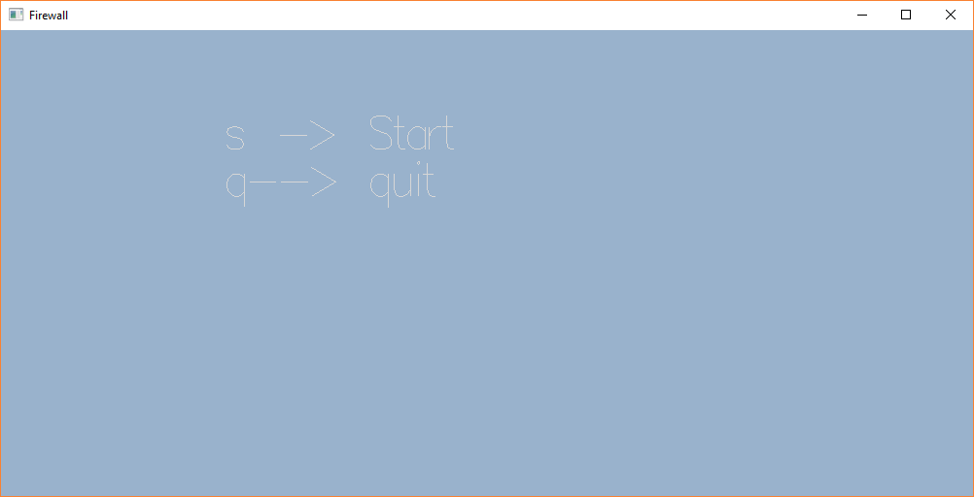

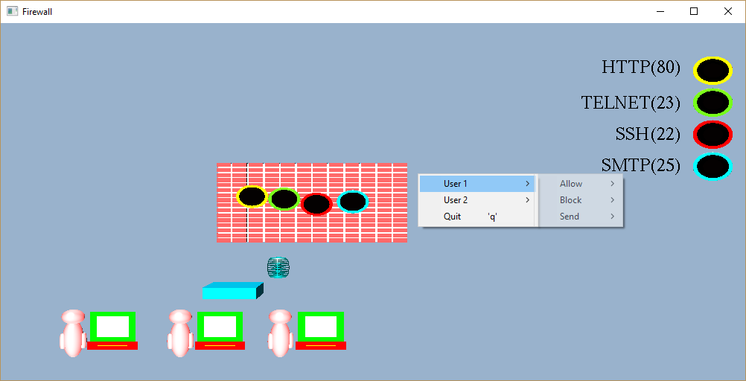

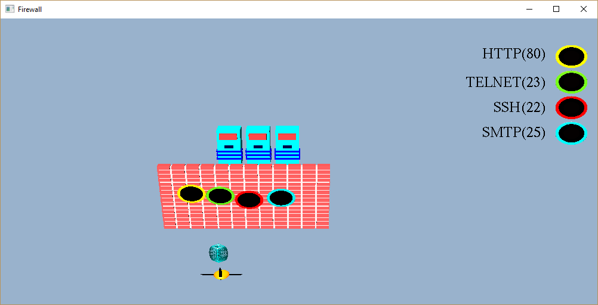

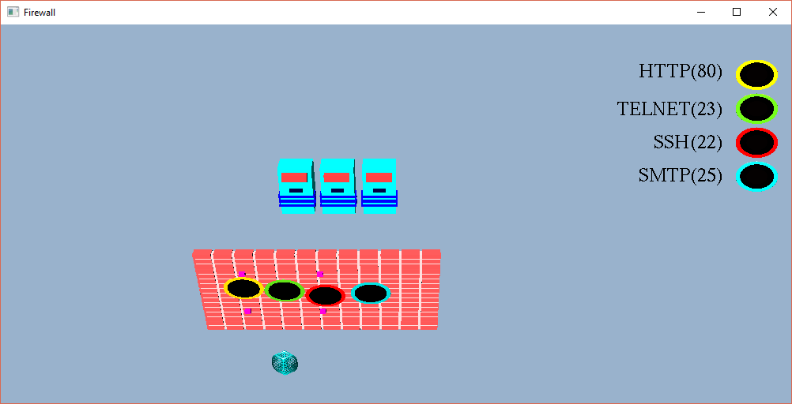

Conclusions

The project “ Firewall” is based on concepts of Network Security.
This program illustrates the concept of network firewall using various functions.
Finally we conclude that this program clearly illustrate the functioning of a Firewall in OpenGL and has been completed successfully and is ready to be demonstrated.

Bibliography

WE HAVE OBTAINED INFORMATION FROM MANY RESOURCES TO DESIGN AND IMPLEMENT OUR PROJECT SUCCESSIVELY. WE HAVE ACQUIRED MOST OF THE KNOWLEDGE FROM RELATED WEBSITES. THE FOLLOWING ARE SOME OF THE RESOURCES :

- TEXT BOOKS :
INTERACTIVE COMPUTER GRAPHICS A TOP-DOWN APPROACH
-By Edward Angel.

- COMPUTER GRAPHICS,PRINCIPLES & PRACTICES
- Foley van dam
- Feiner hughes

- WEB REFERENCES: http://jerome.jouvie.free.fr/OpenGl/Lessons/Lesson3.php
http://google.com
http://opengl.org

